7th Grade Final Exam Study Guide

**DUE on FINAL EXAM DAY ________________________**

**Nature of Science**

1. What is a variable ?
2. What is the dependent variable ?
3. What is the independent variable ?
4. What is a control group ?
5. What are constants ?
6. Measurements
   1. List the base unit for the following :
      1. Mass
      2. Length
      3. Volume
   2. Be able to convert between different units
7. List the steps of the scientific Method
8. What is an observation?
9. What is the difference between a qualitative and quantitative observation ?
10. What is an inference?
11. What is the difference between a theory and a law? Be able to identify each.

**Topic 1**

1. Define the following Words and provide an example
   * Thermal Energy
   * Conduction
   * Convection
   * Radiation
   * Thermal Equilibrium
   * Law of Conservation of Energy
2. Describe the characteristics of a solid, liquid and a gas
3. Which direction does thermal energy move in a system?
4. The expanding of matter when it is heated is known as________________________?
5. What is the difference between temperature and heat?

**Topic 2**

1. Define the following words:

* amplitude-
* reflection-
* refraction-
* diffraction-
* frequency-
* rarefaction-
* wavelength-
* mechanical wave-
* transverse wave-

1. What is the difference between a mechanical wave and an electromagnetic wave?
2. Describe what kind of medium mechanical waves can travel through.
3. What kind of medium can electromagnetic waves travel through?
4. Give one example of each: reflection, refraction, diffraction.
5. What unit is frequency measured?
6. Describe how waves (light and sound) move at different speeds through the different types of matter (solid, liquid, gas).
7. The amplitude of a wave is a direct relationship to how much ______________ the wave has.
8. How does the size of the amplitude in a wave relate to loudness?
9. Describe the relationship between the frequency of a wave and the wavelength.
10. Draw and label the 5 parts of a transverse wave.
11. Draw and label the 3 parts of a longitudinal/compressional wave.
12. What is represented in the diagram below?
13. What are the 2 parts (types) of this wave?
14. Label the different wave types.

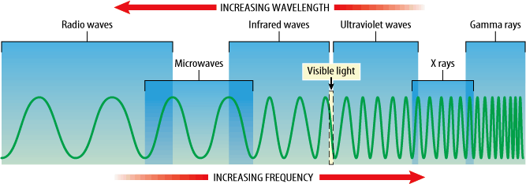

1. Give an example of each type wave or what are used for.

gamma visible light

radio microwave

UV infrared

x-ray